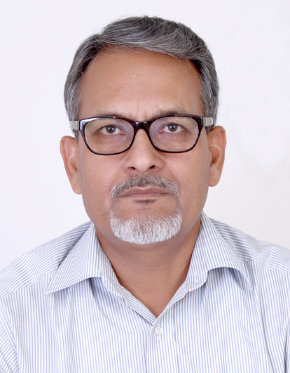
Prof. R. S. Salaria
Professor, Department of Computer Science & Engineering,
Guru Nanak Institutions Technical Campus (Autonomous, NACC A+ & NBA Accredited)
Hyderabad, Telangana.

Head,
Centre of Excellence in Coding & Code Optimization,
Guru Nanak Institutions, Hyderabad, Telangana.

- President, Innovative Foundation for Holistic Education (IFHE) - A Registered Society for the Promotion of Holistic Education aimed at creating Competent Individuals, Good Human Beings, Responsible Citizens, and Committed Nationalists
- An Alumnus of IIT, Delhi; Punjabi University, Patiala (Punjab); Guru Nanak Dev University, Amritsar (Punjab)
- Educator, Author, Motivator, and Social Reformer
- Certified Software Quality Professional, Govt. of India.
- Sun Certified Programmer, SUN Microsystems, USA.
- Sun Certified Trainer, SUN Microsystems, USA.
- Certified Google Educator for Android Development with Kotlin
- Author of 26+ Books on Computer Science, Engineering Mathematics, and Communication Skills
(Authored book on Programming for Problem Solving for BTech 1st yr for AICTE)

Most Popular Books:
All books published with:

Khanna Publishers
4575/15 Ground Floor, Onkar House, Ansari Road, Darya Ganj, Delhi – 110002.
Mobile: 9811541460
Email: contactus@khannapublishers.in
Email: contactus@khannapublishers.in

- Problem Solving and Programming in C
- Programming for Problem Solving with Python
- Data Structures – A Visual Approach
- An Encyclopedia of Programming in C++
- Object-Oriented Programming Using C++

Former Head
Department of Computer Science & Engineering
Thapar Institute of Engineering & Technology (Deemed University), Patiala, Punjab.

Founder Faculty
Department of Computer Science & Engineering, Guru Nanak Dev University, Amritsar, Punjab.

MY CONTRIBUTIONS ON ACADEMIC FRONT (Apart from teaching & writing)

- Regularly conducting Faculty Empowerment Workshops entitled “Effective Teaching – Enlightening and Empowering Educators for Delivering Quality Holistic Education” for educating, motivating and inspiring the faculty. Till date about 70+ such workshops conducted country-wide.

- Regularly conducting brain storming workshops entitled “Programming the Minds – Enlightening and Empowering Young Vibrant Minds through Holistic Education” for guiding, motivating, inspiring and exposing the students about the challenges ahead as per the needs of the industry and the country at large. Till date about 90+ such workshops conducted country-wide.

- At present, focus is on Faculty Empowerment Workshops on New Education Policy-2020, Outcome Based Education, Teaching Learning Methodologies, and Assessments based on Bloom’s Taxonomy.

- Collaborating with academic administrators and policy makers to contribute to rejuvenate higher education in the Country.

- Invited in many International/National Conferences held in India as a Chief Guest, as a Guest of Honour, and as a Keynote speaker.

MY CONTRIBUTIONS ON SOCIAL FRONT

My mantra of life is – Only right understanding is the solution to every problem, and based on this philosophy, I am engaging myself in conducting sessions on -

- Gender sensitization and gender equality.

- Sensitizing the people against the corruption, evils of dowry, honour killings, and domestic violence, etc.

- On empowering the people to become competent, passionate, good human beings, law abiding citizens, and more importantly and true nationalists (whose heart beats for their country).

- Value education and helping the people in recognizing human-to-human relationships and feeling in these relationships, and mutually fulfilling them; recognizing human-to-nature relationship and nurturing them.


(Prof. R. S. Salaria)

